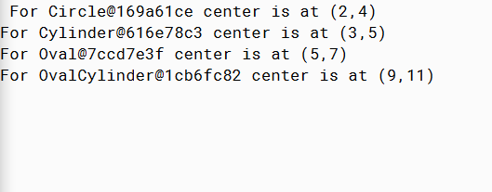

PMR: I’m not sure why the output of my program looks different than the one presented in the lesson, but the object of the program is achieved in the same way. This program was simple, and I enjoyed it.

/\*\*

\* Prints the centers of all of the shapes polymorphically.

\*

\* @author Bijan Tajmir

\* @version 3/2/2015

\*/

public class TestPoly

{

public static void main(String[] args)

{

Circle c1 = new Circle(2, 4, 1);

Cylinder cy1 = new Cylinder(3, 5, 2, 6);

Oval o1 = new Oval(5, 7, 3, 4);

OvalCylinder oc1 = new OvalCylinder(9, 11, 5, 6, 8);

showCenter(c1);

showCenter(cy1);

showCenter(o1);

showCenter(oc1);

}

private static void showCenter(Circle c){

System.out.println("For " + c + c.center());

}

}